1.2 Install the Power BI Desktop application
Note
Power BI Desktop is only available on Windows operating systems. For Mac users consider Boot Camp to setup a Windows partition on your Mac computer. https://support.apple.com/guide/mac-help/use-windows-on-your-mac-mh11850/mac
You must first verify if you have a 32-bit or a 64-bit Windows operating system. To check your operating system type:
- From your Windows operating system, open Control Panel, select System and Security, and then choose System.
- You'll be able to identify if your operating system is 32-bit or 64-bit based on the System type field as shown in the screenshot below.
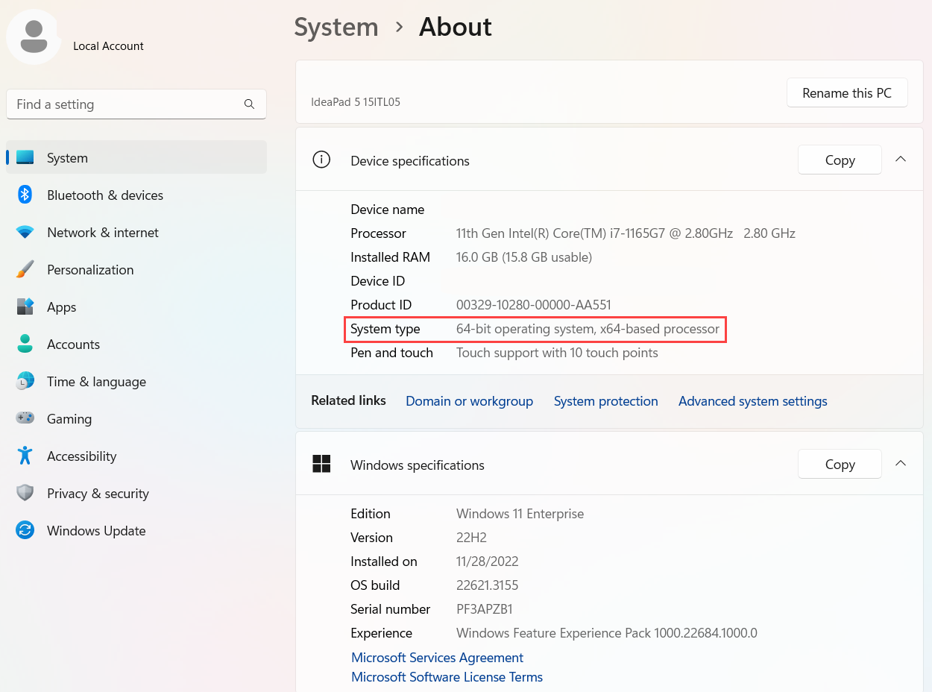
You must download and install Power BI Desktop using any one of the options listed below:
Download and install the Microsoft Power BI Desktop from https://aka.ms/pbiSingleInstaller.

- If you have a 64-bit Operating System, select the PBIDesktopSetup_x64.exe box or if you have a 32-bit Operating System select the PBIDesktopSetup.exe box and select Download.

- After the download is finished, open the file appropriately named either PBIDesktopSetup_x64.exe or PBIDesktopSetup.exe.
- In the pop-up window for the Power BI Setup Wizard, select your preferred Language and select Next.
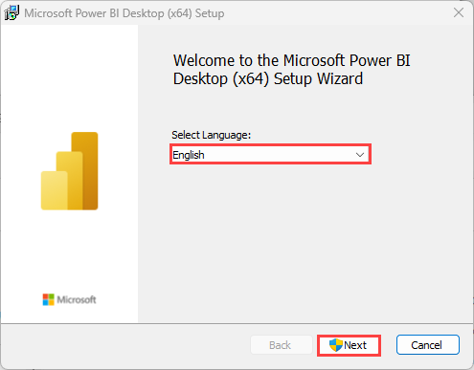
- After the Setup Wizard computes the space requirements, select Next.
- Accept the terms in the License Agreement and select Next.
- Choose where Power BI should be installed and select Next. It's best practice to keep Power BI in the Program Files of your C: drive, and should automatically install to the C:\Program Files\Microsoft Power BI Desktop\ directory.
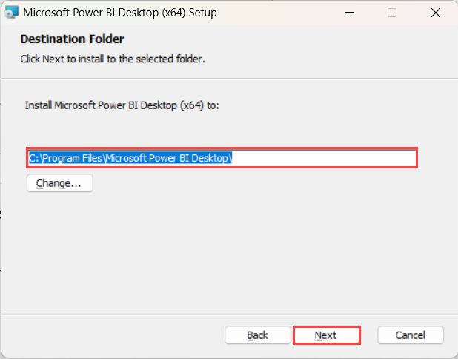
- Select Next after configuring the destination folder, then Install.
- Finally select Finish to complete the installation.
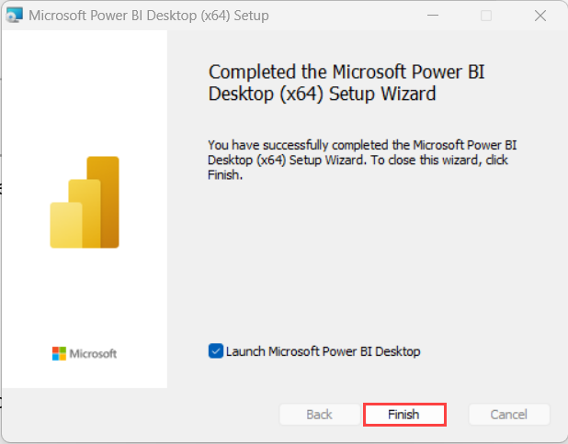
Or if you have Windows 10 or later, you can use the Microsoft App Store to download and install the Power BI Desktop app.
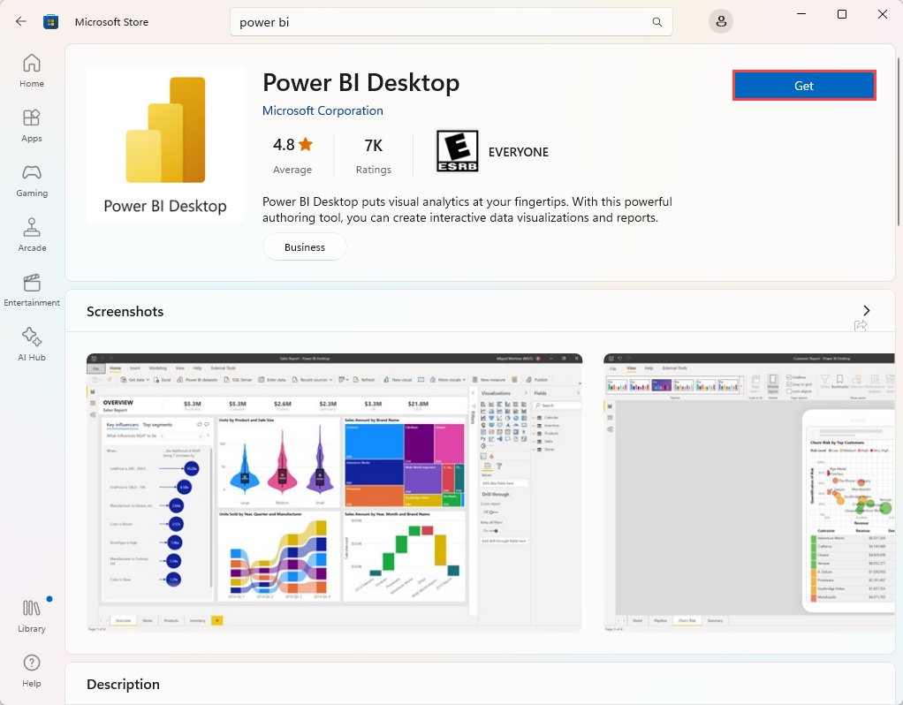
If you already have Power BI Desktop installed, ensure you have the latest version downloaded and installed.

Pin to taskbar
